EXPERIMENT 3
ENERGY AND POWER ANALYSIS OF SIGNALS

OBJECTIVE:
To calculate the energy and average power of given continuous-time and discrete-time signals and classify them as energy signals, power signals, or neither based on their energy and power characteristics.

MATLAB CODING :
% Experiment 3: Energy and Power Analysis
clc; clear; close all;
dt = 0.001;
t = 0:dt:5;
xE = exp(-t);
xP = sin(2*pi*5*t);
E_num = trapz(t,abs(xE).^2);
T0 = 1/5;
idx = t <= 2;
P_num = (1/(t(find(idx,1,'last'))-t(1))) * ...
trapz(t(idx),abs(xP(idx)).^2);
figure;
subplot(2,1,1);
plot(t,xE); grid on;
title('Energy Signal e^{-t}u(t)');
xlabel('Time (s)'); ylabel('Amplitude');
subplot(2,1,2);
plot(t,xP); grid on;
title('Power Signal sin(2pi5t)');
xlabel('Time (s)'); ylabel('Amplitude');
fprintf('Numerical energy = %g\n',E_num);
fprintf('Numerical average power = %g\n',P_num);

OUTPUT :
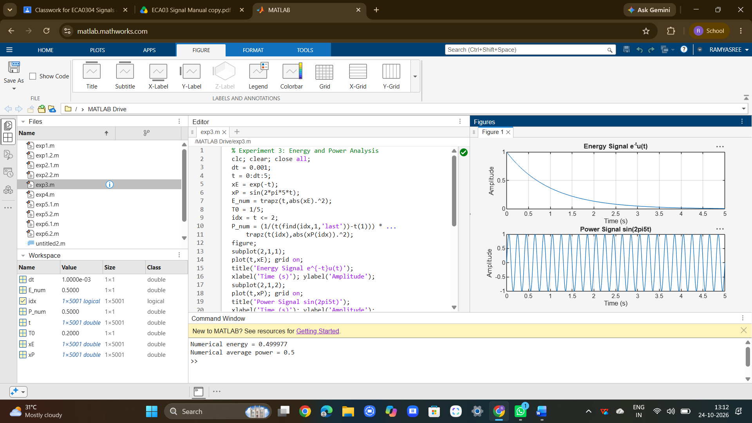

RESULT :
Energy and average power were calculated successfully, and the given signals were classified as energy and power signals based on their energy and power characteristics.

